Lesson 5 Homework | LT 1.1, 1.2, and 1.3 | 4, 5, 7, 11, 15-19 odd, 29-33 odd, 50, 61
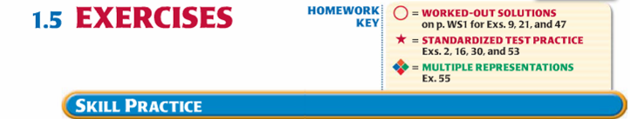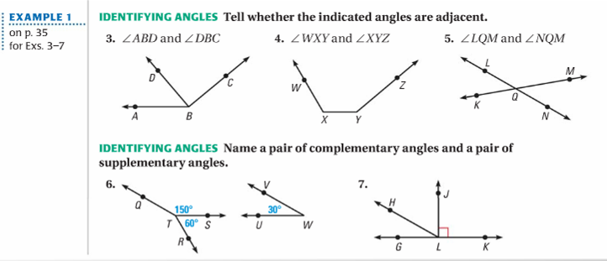

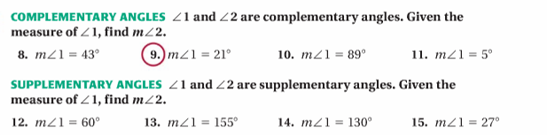

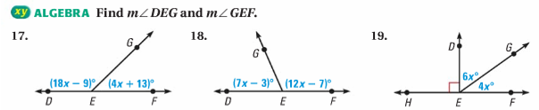

Lesson 5 Homework | LT 1.1, 1.2, and 1.3 | 4, 5, 7, 11, 15-19 odd, 29-33 odd, 50, 61

